Abstract Template for CAMS-Knee OpenSim 2020 Workshop
First I. Author^{1,2}, Second I. Author^{2,1}

¹Institute for Biomechanics, ETH Zürich, Switzerland

²Julius Wolff Institute, Charité – Universitätmedizin Berlin, Germany

Email: anemail@ethz.ch

Introduction
This document serves as an abstract template and contains information about the abstract submission process. All abstracts must be submitted electronically to OpenSim2020@ethz.ch, by the deadline indicated on the website.
The abstract should be prepared using the Microsoft Word template. All abstracts must be submitted as a PDF file and must not be larger than 5 MB. The workshop organisers reserve the right to reject abstracts that do not adhere to this template.

Methods
The abstract is limited to this Letter size page (8.5 in × 11 in, 215.9×279.4 mm), with two columns of text. The top margin should be 20 mm, while left, right and bottom margins should be 15 mm. The column width should be 90 mm. All text should be in font Times New Roman or Times, size 10 pt, except for the figure/table captions, which should be in size 9 pt.
The title (Sentence case bold), authors, and author affiliations should be centred across the top of the page. Use numerical superscripts to distinguish authors who are from different institutions. An email address of the corresponding author must be included. The presenting author should be in bold.
The text within each column should be right- and left-justified, without paragraph indentations. The body of the manuscript should be divided into sections such as Introduction, Methods, Results and Discussion, Conclusions (bold). Spacing (already set in this template): 5 pt for the text, 10 pt before and 5 pt after for the section headers.
Results and Discussion
Figures or tables (if included) should be placed immediately after a paragraph and should be referenced parenthetically in the text (Fig 1). Captions should be placed below each figure and above each table. Tables may extend across two columns when needed, in which case they must be placed at the bottom of the page (Table 1). In Microsoft Word, use “Format Columns” to control which parts of the text are in single column format.
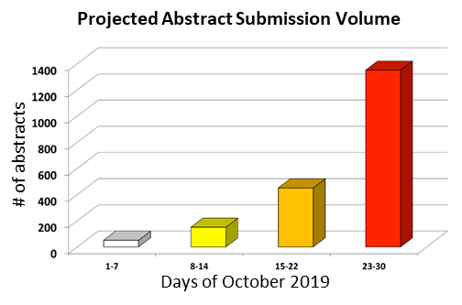
Figure 1: Expected abstracts for OpenSim 2020 in October 2019.
Reference citations within the text are to be made with numbers in square brackets [1,2]. References are to be formatted as illustrated below. Place the journal or book title in Italics, with volume numbers in bold [3].

Conclusions
All abstracts submitted before the deadline (November 1st, 2019) will be reviewed, with an acceptance decision provided before the Early Bird registration deadline (November 15th, 2019). The top abstracts will be invited as oral presentations. Any abstracts received after the deadline will only be considered for poster presentation.

Acknowledgments
Acknowledgments are optional and may specify research funding and resources including organisation name and reference numbers (if applicable).

References
- Author BC et al. (YEAR). Abbrev. Journal, 5(1): 34-36.
- Someauthor ME. (YEAR) Some Book Title; Publisher.
- Taylor et al. (2017). J Biomech, 8(65): 32-39.

Table 1: Interesting data from interesting experiments. The data have been arranged in an interesting manner.
Data | 234 | 23434 | 23 | 232323 | 443 | 3432 | 234 | 32423 | 23423
Other | 23423 | 23423 | 233 | 234323 | 3243 | 43242 | 23434 | 234 | 342

